Rain Shelter Construction Protocol
Written by A. Semerdjian, S. Lin & G. Napolitano
Edited by Endicott 7/2/2015

*Sections labeled fall installation, are completed each year during the fall re-installation of shingles and irrigation parts.
*Please refer to the irrigation system parts list in help identifying specific parts.

TASK | PERSON-HOURS/SHELTER
EMT prep | 24 hours
Rebar prep | 2 hours
Gutter prep | 8 hours
Foundation prep | 2 hours
Shingle prep | 16 hours
Site prep | 2 hours
Rebar installation | 6 hours
Frame installation | 6 hours
Gutter installation | 8 hours
Fall Installation: Shingle installation | 8 hours
 | TOTAL = 82 hours

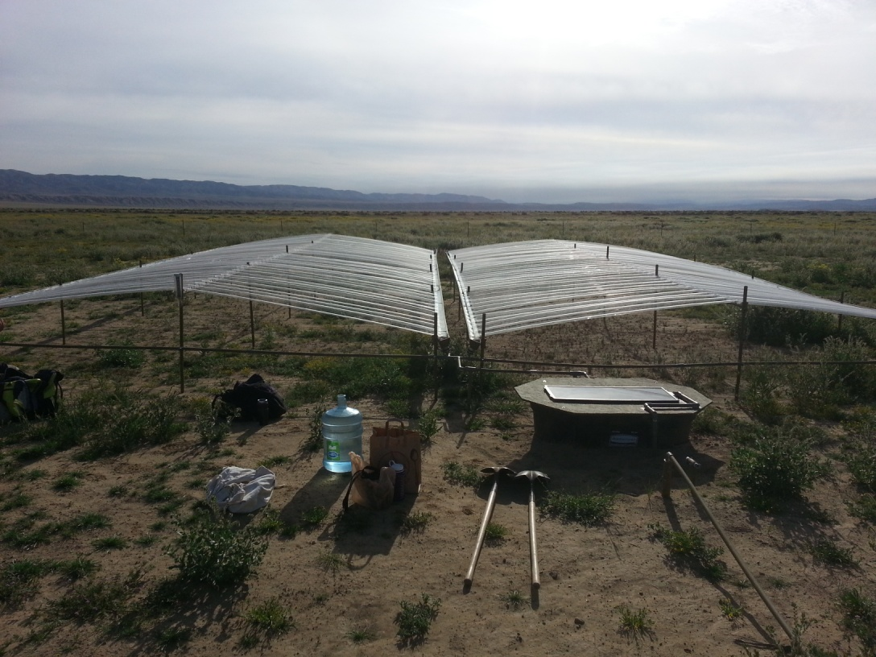
Completed rain shelter with irrigation system

Step 1: EMT prep, 24 person-hours/shelter

MATERIALS NEEDED:
- 1in x 10ft EMT pipe (38)
- 2in x 4in x 10ft length of wood (2)
- 2in Roofing nails (5)
- One-socket kee klamp steel fittings (12)
- Two-socket kee klamp steel fittings (16)
- Three-socket kee klamp steel fittings (4)
- Killz all-purpose white primer (<1 gallon)
- Behr’s premium outdoor paint, olive (<1 gallon)

TOOLS NEEDED:
- Pipe cutter or chop saw equipped with metal cutting wheel
- Measuring tape
- Marker
- Power drill
- 5/32in split point or pilot point drill bit for metal
- Center punch
- Roofing Hammer
- Work gloves
- Safety glasses
- Paint brushes (2)
- Containers filled with water for washing paint brushes (2)
- Saw horses (2)

OVERVIEW: EMT pipe is used to build the “arms”, “legs”, and “support beams” of the shelter, all of which are connected to one another using kee klamp steel fittings. The arms are the horizontal pipes that support the shingles and gutters and the legs are the vertical pipes that slide onto rebar and support the arms. The support beams intersect the legs at the center of each shelter to provide rigidity to the structure. There are two types of legs and two types of arms: “high legs” measure 4ft long while “low legs” measure 3ft long and neither require any drilling, “low arms” require 11 pre-drilled holes at precise locations for shingle installation while “high arms” require 22 of these holes. For each shelter you will need to make 10 high legs, 20 low legs, 16 low arms, 8 high arms, and 4 support beams. Cut edges are sharp, so wear gloves when moving/handling pieces. Always wear safety glasses and work gloves when operating power tools.

LEGS:
- Take ten 10ft EMT pipes and make two marks on each of them at 3ft and 6ft using the tape measure and marker
- Cut the pipes at the marked locations using the pipe cutter or chop saw
- This will produce twenty 3ft low legs and ten 4ft high legs

SUPPORT BEAMS:
- Using the measuring tape and marker, mark four 10ft lengths of EMT pipe at 91.5in
- Cut the pipes at the marked locations using the pipe cutter or chop saw
- This will produce four support beams

MEASURING/DRILLING FRAME:
- Nail the two 2in x 4in x 10ft pieces of wood together at a 90degree angle.
- Use the marker to mark the wood 7.4cm from the left end, and then move to the right marking every 11.2cm until you have made twenty-two marks in total
- This frame will be used to mark the EMT pipes being used as arms at the precise locations where they will need to be drilled

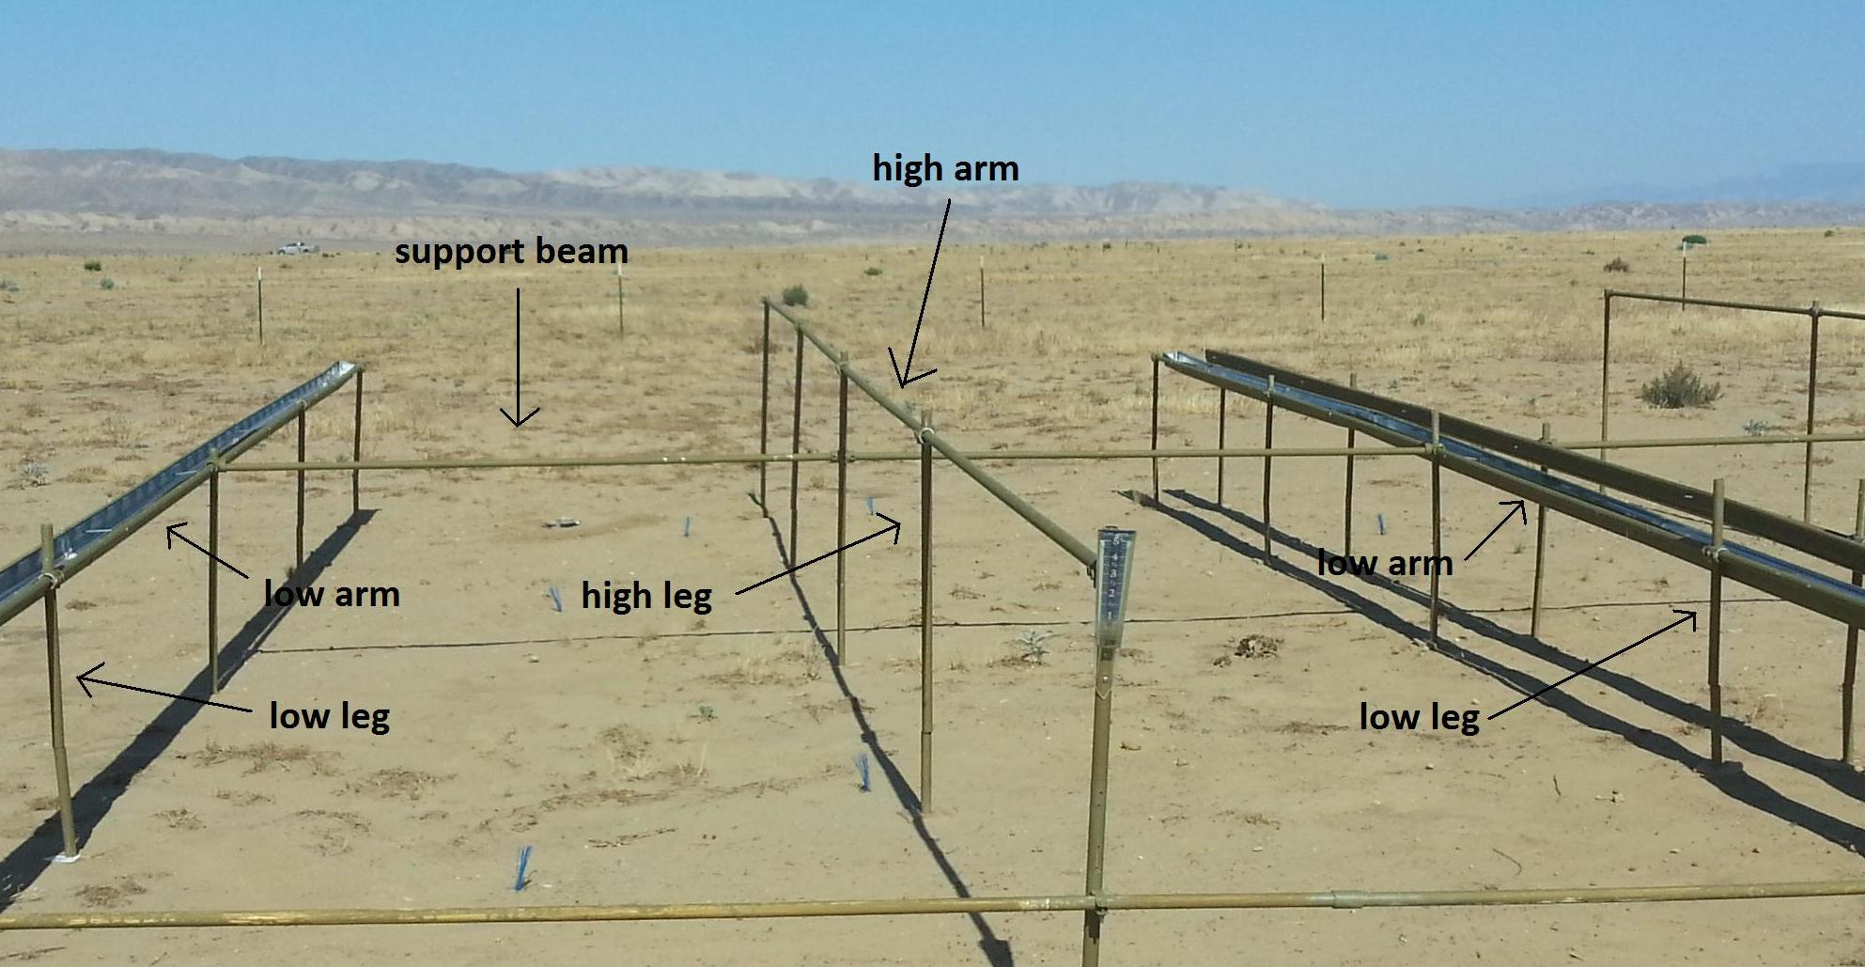Diagram of support beams, arms, and legs

ALL ARMS:
- Use the marker and a measuring tape to mark twenty-four of the 10ft EMT pipes at 250cm and cut each of them to this length using the pipe cutter or chop saw
- Use the straight edge of your wooden frame and the marker to draw a straight line down the length of each pipe.

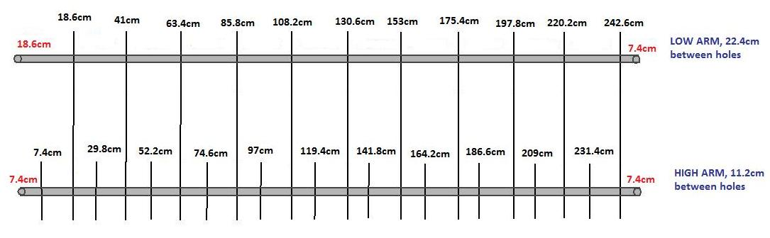
Drilling locations for high arms, low arms

HIGH ARMS:
- Take eight of the 250cm pipes and draw a second straight line down the length of each of them 0.5 cm below the first line, then set the remaining sixteen 250cm pipes aside to be used as low arms
- Place one of these pipes on the frame and slide it down so that it is even with the left edge of the frame
- Use the marker and pre-measured marks on the frame to mark along the upper straight line, with the first mark being made 7.4 cm from the left end of the pipe
- Continue to mark ten more points on this line with each point 22.4 cm apart. (Every other mark on the frame, starting with the first mark)
- Mark a point on the lower straight line 18.6 cm from the end of the pipe. (The second mark on the frame)
- Mark ten more points on this line with each point 22.4 cm apart. (Every other mark on the frame, starting with the second mark)
- There should be twenty-two staggered marks on the pipe that are 11.2cm away from each other and 0.5cm above or below one another with an extra 7.4cm on either end of the pipe
- Repeat this process to make the remaining seven high arms

LOW ARMS:
- Use the sixteen 250cm pipes you have set aside to make low arms
- Place one of these pipes on the frame and slide it down so that it is even with the left edge of the frame
- Use the marker to mark the pipe along the straight line at a location that is 18.6cm from the left end of the pipe (the second mark on the frame)
- Move to the right and make another mark along this straight line at a location that is 22.4 cm from the first mark you made on the pipe (this location should be the fourth mark on the frame). Continue to mark the pipe with marks 22.4 cm apart (every other mark on the frame, starting with the second mark)
- There should be 11 marks in total all in a straight line with an extra 18.6cm on one end of the pipe and an extra 7.4cm on the other end of the pipe
- Repeat this process to make the remaining fifteen low arms

ALL ARMS ONCE THEY HAVE BEEN MARKED:
- Use the power drill equipped with the 5/32in metal bit to drill a hole where the marks intersect with the straight line (if needed a center punch can be used to make a dent at each drill location to facilitate this process, place the center punch where you wish to drill and strike it with a hammer)
Aerial picture of pipes with holes
ALL PREPPED PIPES AND EMT FITTINGS:
- Set up a painting station. Lay down a large tarp and secure corners. Space out the two saw horses on top of this tarp. Fill up two containers of wash water to keep paint and primer brushes separate.
- Lay a group of pipes out on the saw horses and paint one side with outdoor primer suitable for galvanized metal, then flip them over and paint the other side with the primer
- Once the primer dries, use a separate brush to coat one side of each pipe with the olive paint, allow this to dry, then flip them over and paint the other side
- Set this batch of pipes aside to dry and repeat the process until all pipes are painted
- Remove the saw horses and lay out the EMT fittings on the tarp
- Coat one side of the EMT fittings with primer taking care not to clog the adjustable hex fixtures, allow this side to dry, then flip them over and apply primer to the other side
- Once the primer has dried, paint one side of the EMT fittings with the olive paint, again taking care not to clog the adjustable hex fixtures, allow this side to dry, then flip them over and paint the other side
- Once all of the pipes and EMT fittings have dried they are ready for installation

Step 2: Rebar prep, 2 person-hours/shelter

MATERIALS NEEDED:
1/2in x 10ft rebar (15)

TOOLS NEEDED:
- Rebar cutter or chop saw equipped with metal cutting wheel
- White sharpie
- Measuring tape
- Safety glasses
- Work gloves

OVERVIEW: Each shelter needs a total of ten 6ft rebar pieces and twenty 4ft rebar pieces. Ends of cut rebar are sharp and pose a risk of impalement if left exposed in the ground. Be careful and wear gloves when handling rebar pieces. Make sure to store rebar lying flat and not sticking up. Always wear safety glasses and work gloves when operating power tools.

REBAR PREP:
- Use the tape measure and white sharpie to mark ten of the 10ft rebar lengths at 4ft and cut each of these pieces at this location. This will give you ten 6ft lengths and ten 4ft lengths
- Use the tape measure and white sharpie to mark the remaining five of the 10ft rebar lengths at 4ft and 8ft and cut each of these pieces at this location. This will give you ten more 4ft lengths and ten 2ft lengths which can be set aside for later use
- After all the rebar is cut, use the measuring tape and white sharpie to mark each of the 6ft and 4ft lengths of rebar at their center point. These marks will serve as a guide for how far to drive the rebar into the ground

Step 3: Gutter prep, 8 person-hours/shelter

MATERIALS NEEDED:
- 4in x 10ft steel K-style gutters (13)
- 4in steel K-style gutter end drops (4)
- 4in steel K-style gutter slip connectors (16)
- 4in steel K-style gutter left end caps (4)
- 4in steel K-style gutter right end caps (4)
- Killz all-purpose white primer (<1 gallon)
- Behr’s premium outdoor paint, olive (<1 gallon)

TOOLS NEEDED:
- Measuring tape
- Marker
- Chop saw equipped with metal cutting wheel
- Safety glasses
- Work gloves

OVERVIEW: There are four lengths of gutter needed per shelter, one length on each set of low arms. Each of these lengths of gutters is made up of four separate gutter pieces, three 10ft pieces and one 29in piece. These pieces are held together by slip connectors and each length will have a gutter drop installed at the low end and gutter caps installed at both the low and high ends. The gutters will be drilled in the field at the time of installation and secured to the frame with nuts and bolts. Always wear safety glasses and work gloves when operating power tools.

GUTTER PREP:
- Use the measuring tape and marker to mark one of the 10ft pieces of gutter at 29in, 58in, 87in, and 116in
- Use the chop saw equipped with a metal cutting wheel to cut this piece of gutter at each of the marks you have made so that you end up with four separate 29in pieces, discard the remaining 4in scrap piece
- Set up a painting station as was done for the EMT pipes and lay out the twelve remaining 10ft gutter pieces on the saw horses.
- Apply primer to the outside of all of the gutter pieces leaving approximately 1in unpainted at either end of each gutter piece so that the pieces can slide into the slip connectors
- Once the primer has dried apply olive paint to the outside of each of these gutter pieces again leaving approximately 1in unpainted at either end of each gutter piece
- Repeat this process for the four 29in gutter lengths and four gutter end drops
- Lay out the sixteen gutter slip connectors, four left end caps, and four right end caps on the tarp
- Apply primer to the outside of the slip connectors and the outside of the end caps taking care not to clog the inside of the slip connectors
- Once the primer has dried, paint all of these slip connectors and end caps with the olive paint, again taking care not to clog the inside of the slip connectors
- When all of the gutter pieces and fixtures have dried they are ready for installation in the field

Step 4: Foundation Prep, 2 person-hours/shelter

MATERIALS NEEDED:
Oriented strand board 7/16in x 4ft x 8ft

TOOLS NEEDED:
Measuring tape
Marker
Straight edge
Skill-saw
Saw horses (2)
Vise clamps
Power drill
9/16in drill bit
Safety glasses
Work gloves

OVERVIEW: Each shelter leg will need a foundation to prevent the EMT pipe from sinking into the ground. This foundation will consist of small wooden “feet” which are essentially just 5in squares of oriented strand board (OSB) with a hole drilled in the center of each of them that slide over each piece of rebar before installing the EMT legs. As there are 30 legs per shelter, you will need 30 of these feet per shelter. Always wear safety glasses and work gloves when operating power tools.
Picture of foundation for EMT pipe
FOUNDATION PREP:
- Use the measuring tape and marker to mark a rectangle on the OSB that measures 25in x 30in
- Secure the OSB to the saw horses using the vise clamps and carefully cut out this rectangle using the skill-saw
- Set the extra OSB aside for later use
- Use the measuring tape and marker to mark the 25in x 30in rectangle every 5in on each of the rectangle’s four sides, and then use the straight edge to connect these marks to one another so that you end up with the outline of thirty 5in x 5in squares on this rectangle
- Secure the OSB rectangle to the saw horses using the vise clamps and carefully cut along each of the lines you have drawn so that you end up with thirty individual 5in x 5in squares
- Use the measuring tape and sharpie to mark the center point of each of these squares and drill at this location with the 9/16in drill bit
- This will yield thirty wooden feet

Step 5: Shingle prep, 16 person-hours/shelter

MATERIALS NEEDED:
- 1/4in x 5in x 96in clear acrylic w/plexiglass specs via TAP Plastics (176)
- 2in x 6in x 8ft lengths of wood (5)
- #8 x 2in self-tapping screws (10)
- 1in x 10ft EMT pipes (2)
- 5-pack 36in white horizontal foam closure strips (7)

TOOLS NEEDED:
- Measuring tape
- Marker
- Power drill
- 3/16in drill bit
- Phillips #2 driver bit
- 8ft acrylic heater
- 2in binder clips (8)
- Rocks or weights for shingle molding (2)
- Knife
- 1in roofing nail (1)
- Safety glasses
- Work gloves

OVERVIEW: The roofing of each rain shelter is composed of 176 acrylic shingles, each of which will need to be molded by hand to a 120degree angle and drilled at precise locations. This molding is achieved through the use of an acrylic heater and cooling molds that are constructed to the proper angle. The acrylic is flexible before heating yet fragile once it is shaped so take care not to crack the brittle shingles once they have been prepared. Wear gloves when molding the shingles to avoid burning yourself on the heater and always wear gloves and protective eyewear when operating power tools.

SHINGLE PREP:
- Lay one of the unheated shingles flat on one of the 2in x 6in x 8ft pieces of wood and use the measuring tape and marker to draw one dot on it precisely at the center of the rectangle 3cm from the far left edge and one dot precisely at the center of the rectangle 5cm from the far right edge.
- Keep the shingle on the wood so as to not damage the surface below by accidentally drilling into it, and use the power drill and 3/16 drill bit to drill a hole at each of these locations
- Double check the exact locations of the holes with the measuring tape. You want these holes to be precise because this will serve as your “guide shingle” for drilling all of the other shingles.
- Next, take a stack of 5 more unheated shingles and stack them on top of one another so that their edges are exactly lined up with each other
- Place your pre-drilled guide shingle on top of this stack with its edges precisely lined up with the others and use its pilot holes as a guide to drill straight down through the stack of shingles. Be very careful to keep the drill pointing straight down and not at an angle during this process or the shingles will not be drilled in the proper location. (You may want to use the measuring tape to occasionally double-check your work)
- Peel the plastic coating off of either side of each shingle and set them aside for molding
- Repeat this process until you have prepared 176 shingles

SHINGLE MOLDING:
- Use the power drill and self-tapping screws to build a cooling mold by screwing together two of the 2in x 6in x 8ft pieces of wood so that they form an obtuse 120degree angle with one another. This angle must be precise, as all manufactured shingles need to have an edge to edge width of 4.5in.
- Repeat this process to build a second identical mold
- Set up the two molds, eight binder clips, two EMT pipes, and the acrylic heater on a table and plug in the heater to allow it to warm up for at least 10 minutes. Prop up the two molds using the 2in x 6in x 8ft drilling board so that they do not rock back and forth
- Once the heater has warmed up place a prepped shingle on it so that the two holes and the center line of the shingle are lined up directly above the heating rod and place a rock or small weight at each edge of the shingle to keep it pressed to the heater (it is important to make sure that the shingle stays centered on the heater while it warms up to make sure that it will bend directly along the center line)
- Once the shingle has become pliable along the center line (approximately 90 seconds) remove the weights and lift the shingle off of the heater, bend it in half, and press it into one of the molds. Then quickly clip the shingle to the mold with the binder clips by placing one clip on the lower half and one clip on the upper half at each end of the shingle and place the two EMT pipes on top of the shingle to weigh it down in the middle for the cooling process.
- Place another shingle on the heater and repeat the process to mold another shingle, clipping this one to the second unoccupied mold. Once this shingle is clipped to the mold remove the EMT pipes from the other shingle which should now be relatively cool and place the pipes on top of this shingle.
- Remove the first shingle from the mold (it should now be cool enough to hold its shape) and set it aside so that there will be space on the mold for when the next shingle is ready to come off the heater.
- Place another shingle on the heater and repeat this process until you have 176 molded shingles (alternate cooling molds each time to allow one shingle to cool while the other is being molded)

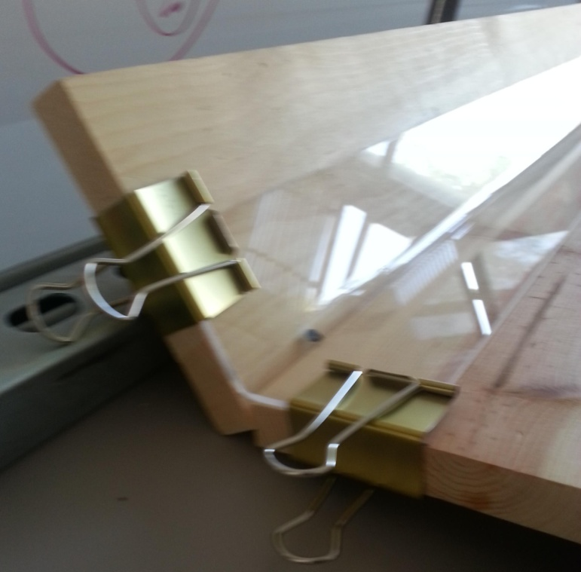
Shingle clipped to cooling mold

FOAM PREP:
- Cut each length of horizontal foam closure strips into eleven pieces by using the knife to slice through each “crest” until you have 352 pieces
- Each piece of foam should be u-shaped and resemble a valley with a hill on either side
- Once the foam has been cut, use a roofing nail to poke a hole at the exact center of the “trough” of each of the foam pieces. This marks the location where the screw will be installed.

Step 6: Grid prep, 2 person-hours/shelter

MATERIALS NEEDED:
- 140m of utility cord
- 8 wooden stakes
- Flagging tape
- Duct tape

TOOLS NEEDED:
- Measuring tape
- Sharpie
- Scissors
- Utility knife

OVERVIEW: A re-usable grid made of utility cord will be constructed to plot out the precise location for the installation of each piece of rebar, foot, and leg at each shelter site. Two lengths of marked string will be stretched out east to west to mark the spacing of legs on the same arm and two lengths of marked string will be stretched out north to south to mark the spacing of legs on different arms.

EAST TO WEST GRID LINES:
- Prepare four wooden stakes with two small notches on either side of each of them at equal heights.
- Measure out a 35m length of utility cord.
- Tie each end securely to a stake, with the utility cord secured into the notches. Hammer the stakes into the ground so that your string is stretched out and taut.
- Beginning at one end, measure and precisely mark the utility cord at 12in from the stake. This will be the location of the first leg along the line of arms.
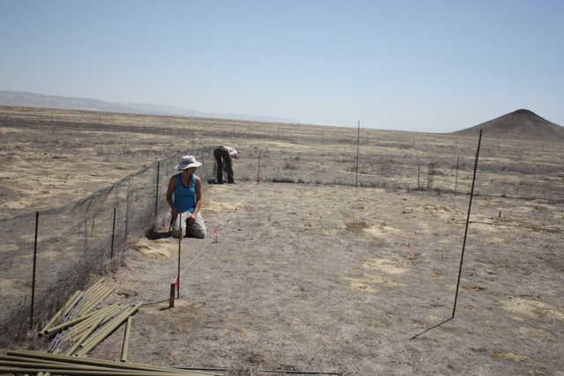
- Tie and knot a small piece of flagging tape tightly around this first mark. To make sure the flagging does not slide, secure small pieces of duct tape on either side of the flagging.
- You will mark and flag a second point at 98.7in from the first point. This is the location of the second leg along the line of arms.
- Continue marking and flagging at 98.7in intervals until you have a total of 5 points, evenly spaced. Be as precise as possible.
- Repeat this process to create a second, identical set of stakes and utility cords.
- Label each setof stakes with the sharpie, “E-W 98.7in”

NORTH TO SOUTH GRID LINES:
- Measure out a 35m length of utility cord.
- Tie each end securely to a stake, with the utility cord secured into the notches. Hammer the stakes into the ground so that your utility cord is stretched out and taut.
- Beginning at one end, measure and precisely mark the utility cord at 12in from the stake. This will be the location of the first leg (low leg).
- Tie and knot a small piece of flagging tape tightly around this first mark. To make sure the flagging does not slide, secure small pieces of duct tape on either side of the flagging.
- You will mark and flag a second point at 92.5in from the first point. This is the location of the second leg (high leg).
- Mark and flag a third point at 92.5in from the second point. This is the location of the third leg (low leg)
- Next, mark and flag a fourth point at 16in from the second point. This is the location of the fourth leg (low leg). The 16in gap is where the middle line of gutters will be.
- Mark and flag a fifth point at 92.5in from the fourth point. This is the location of the fifth leg (high leg).
- Mark and flag a sixth point at 92.5in from the fifth point. This is the location of the sixth leg (low leg).
- Repeat this process to create a second, identical set of stake and utility cord.
- Label each set with of stakes with the sharpie, “N-S 92.5in”

STEP 7: Rebar installation, 6 person-hours/shelter

MATERIALS NEEDED:
- 6ft lengths of 1/2in rebar (10)
- 4ft lengths of 1/2in rebar (20)
- High legs - EMT pipe (10)
- Low legs - EMT pipe (20)

TOOLS NEEDED:
- Grid from “Step 6”
- Mallet
- 24in post driver
- Work gloves

OVERVIEW: Rebar will be installed at the precise locations marked on the grid. The 4ft lengths of rebar will be driven 2ft into the ground to support the low legs. The 6ft lengths of rebar will be driven 3ft into the ground to support the high legs. Rebar is sharp and can impale you, so be careful and make sure to place a high or low leg on your rebar soon after you’ve driven it in. Do not leave standing rebar exposed.

GRID SET-UP:
- At the shelter site, stretch out an E-W grid line east to west, along the northernmost boundary of the shelter site and hammer in the stakes. Make sure your utility cord is taut.
- Next, stretch out a N-S grid line north to south, along the westernmost boundary of the shelter site. Line up your first point on the N-S line so that it overlaps the first point on the E-W line. Hammer in the stakes once you’re lined up. You now have a 90-degree “L” grid.
- Next, stretch out and line up the second E-W grid line along the southernmost boundary so that the westernmost mark on this line overlaps southernmost mark on your west line.
- Then, stretch out and line up the second N-S grid line along the easternmost boundary so that its northernmost and southernmost marks overlap with the easternmost marks on your east and west lines.
- Make sure the end marks on each of your lines overlap the marks on the lines they run perpendicular to at each end, there should now be a rectangular grid set up with 90degree corners.

REBAR INSTALLATION:
- Beginning at one edge of the grid, place and pound in the correct length of rebar (4ft for low legs, 6ft for high legs) at the marked locations using the mallet or post driver. Stop when each piece of rebar is half-way in the ground, the location marked by the white sharpie. Work along this edge down one of the lines, driving rebar in at each flagged point.
- Once you’re done with the first row, move the line you had positioned there and stake it in at the next row so that flags on its edges overlap with the next set of flags down on the lines running perpendicular to it.
- Again place and drive your rebar down the line at each flagged point.
- Continue the process until you have placed rebar at each of the thirty points in the grid.
- Step back to make sure the rebar is straight and lined up at every point.
- Slide a wooden foot onto each piece of rebar
- Slide the low legs and high legs onto the rebar so that they rest on top of the wooden feet (make sure to carry out this step immediately after installation so that rebar is not left exposed in the ground)
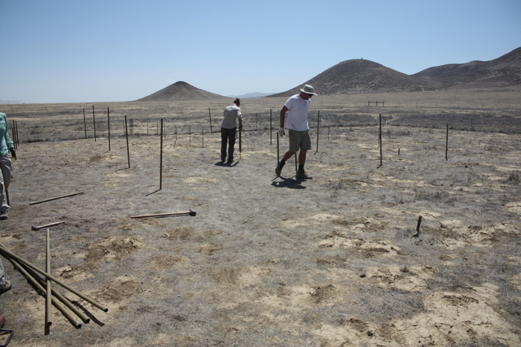
Step 8: Frame installation, 6 person-hours/shelter

MATERIALS NEEDED:
- High Arms (8)
- Low Arms (16)
- One-socket kee klamp steel fittings (12)
- Two-socket kee klamp steel fittings (16)
- Three-socket kee klamp steel fittings (4)

TOOLS NEEDED:
- 1/4in allen wrench / hex key
- Yard-length level

OVERVIEW: The shelter frame is made up of arms, legs, and support beams that are connected to one another using adjustable kee-klamp fittings. Each shelter is divided into two identical halves, a north half and a south half, each with a southern row of low arms, a northern row of low arms and one row of high arms in the middle. It is important to keep track of exactly where each unique, leg, arm, and fitting is placed.

ARM SETUP:
- Once the rebar, feet, and legs have been set up as described in the “Site prep” and “Rebar installation” sections of this protocol, lay out the arms in the positions in which they will be installed
- Beginning with the two southern rows of low arms (one southern row of low arms on the south half of the shelter and one southern row of low arms on the north half of the shelter), lay out four low arms between the legs in each row so that the long end of each pipe, the side with 18.6cm extra pipe before the first hole, faces west
- Next, move to the two northern rows of low arms (one northern row of low arms on the south half of the shelter and one northern row of low arms on the north half of the shelter), and lay out four low arms between the legs in each row so that this time the short end of each pipe, the side with 7.4 cm extra pipe before the first hole, faces west (turn the pipes 180degrees from their orientation in the southern low arms)
- Then, lay out the high arms along the two middle rows of each shelter half so that the first hole 7.4cm from the end of each pipe is staggered to the north and the second hole 18.6cm from the end of each pipe is staggered to the south
- The pipes should be lined up so that the holes on the low arms are even with the closest row of holes on the high arms
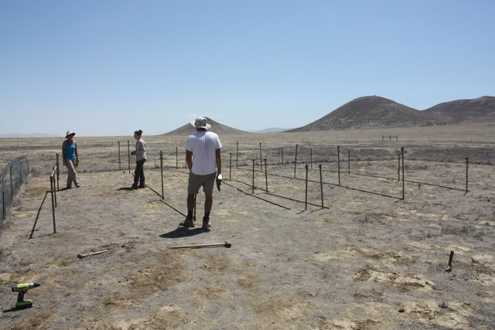

JOINT FITTING SETUP:
- Place one-socket joint fittings on the legs at both ends of each row of arms (along the six northernmost and six southernmost legs). For the low arm rows, make sure the side of the fittings with the hex fixtures face inward towards the high arm row; the smooth side will face outward, making it easier to install gutters on the low arms. For the high arm rows make sure the side of the fittings with the hex fixtures face all in the same direction, either inwards or outwards
- Place three-socket joint fittings on the center legs of the low arm rows with the hex fittings facing upwards. These will connect the support beams the rest of the frames
- Place two-socket joint fittings on all other legs, with two two-socket joints placed on the center legs of each of the high arm rows (one of these fittings will connect to the arms while the other connects to the support beams). As you do this, make sure that the side of the fittings with the hex fixtures faces in the same direction as the single-socket fittings did

CONNECTING ARMS AND ADJUSTING FOR SLOPE:
- Insert the arms into the fittings on either side of them, slide them up to the top of each leg, and secure them in that position using the 1/4in allen wrench so that the holes on the low arms are twisted approximately 0.25cm outwards, facing slightly away from the high arms on that half of the shelter, while the 0.5cm space between the staggered holes on the high arms faces directly upwards.
- Repeat this process until all of the arms have been attached to the legs and EMT fixtures and are positioned at the top of the EMT pipes
- Next insert the support beams and secure them into the fittings in the center of the shelter so that they run perpendicular to the rows of arms
- After all the pipes are installed they need to be sloped so that water in the gutters will run “downhill” toward the irrigation plot at that site.
- Determine which side of the shelter (the east or west) is nearest the irrigation site and find the highest low leg on that side based on the natural slope of the ground
- Move the fitting on that leg up or down until it is positioned 18in above the ground
- Then walk down that row of legs to the opposite end and move the fitting on that leg as high as it will go to maximize slope
- Next, adjust the remaining three fittings on this row of low arms to distribute this slope evenly so that each pipe has the same amount of slope on it (the level can be useful in this task). When slope has been properly setup the four pipes making up a given row of arms should appear as if they could be one continuous pipe, instead of four separate pipes with each one slanted more or less than the one next to it.
- Once this one row of low arms has been properly sloped move to the central high leg on this half of the shelter and slide the fitting that connects to the support beam up or down until the support beam is perfectly level with the central fitting on the row of low arms you have set up (use the level to confirm this)
- Then, adjust the central fitting on the other row of low arms that has not yet been set up so that the support beam on that side of the high legs is level with the other one. This assures that the central points on your two rows of low arms are level with one another.
- Next, moving from this middle point outwards and adjust the slope of this set of low arms to match that of the one that has been already set up. Do this using the level and your best judgement. When viewing the frame from the north or south side the slope of each row of low arms should appear to be parallel with one another.
- Finally, adjust the row of high arms on this half of the shelter. Begin at the central high leg and use the ruler on the level to adjust the distance between the top of the fitting connected to the support beam and the top of the fitting connected to the high arm to 12in (this assures that the high arms are positioned exactly 1ft higher than the low arms). Then level out the slope of this row of arms so that it is parallel with the slope of the two high arms on this half of the shelter. This half of the shelter should now be setup with the same amount of slope on each row of arms, the support beams perfectly level with one another, and the high arms positioned 1ft above their corresponding low arms
- Move the center of the low end of the shelter and use the level to adjust the fitting on the second half of the shelter here to the same level as the fitting on the half of the shelter you have already adjusted
- Repeat the process described above to apply the same amount of slope to the second half of the shelter
- When you are finished, all arms on both halves of the shelter should run parallel to one another with the four fittings in each north to south line of low legs and the two fittings in each north to south line of high legs positioned level with one another

STEP 9: Gutter installation

MATERIALS NEEDED:
- 4in x 10ft steel K-style gutters (12)
- 4in x 29in steel K-style gutters (4)
- 4” steel K-style gutter end drops (4)
- 4” steel K-style gutter slip connectors (16)
- 4” steel K-style gutter left end caps (4)
- 4” steel K-style gutter right end caps (4)
- ¼” x 6” zinc-plated, fully threaded hex bolts (32)
- ¼” zinc-plated washers (32)
- ¼” zinc-plated hex nuts (64)
- Eco-bond gutter sealant (<1 tube)

TOOLS NEEDED:
- Power Drill
- 1/4in pilot point drill bit for metal
- Adjustable crescent wrench
- Sharpie
- Caulking gun
- Latex gloves
- Safety glasses
- Work gloves

OVERVIEW: Gutters will be installed on each of the low arms in the field. This involves drilling both the arms and the gutters themselves at particular locations and securing them with a set of nuts, bolts and washers, one in the middle of each gutter segment and one at the low end of each gutter segment (8 sets of bolts per complete length of gutter). Once the gutters have been installed they will need to be caulked at each slip connector and end cap to prevent leakage. Always wear gloves and protective eyewear when operating power tools.

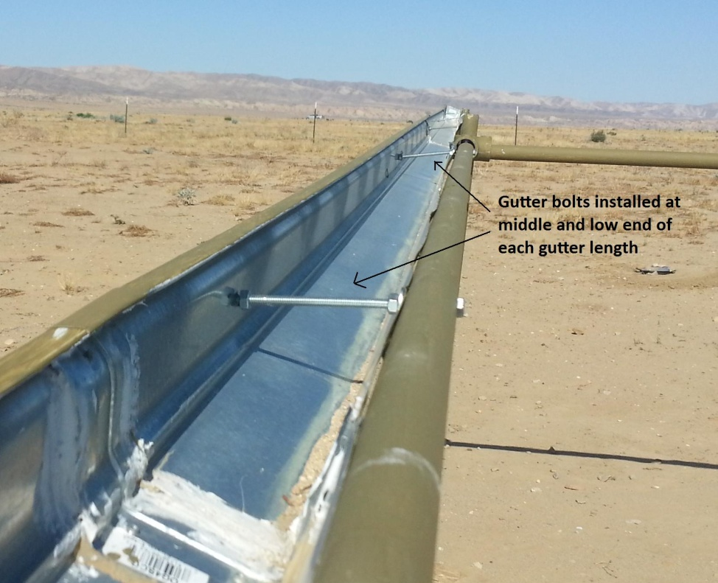
Install two bolts per segment of gutter

GUTTER INSTALLATION:
- Begin at the highest end of one of the lengths of low arms. Use the power drill and the 1/4in pilot point drill bit to drill straight through both sides of the EMT pipe between the EMT fitting and the first shingle hole, making sure to keep the drill straight so that a line drawn between the two holes would be level with the ground
- Next, line up the short 29in length of gutter so that it is lined up evenly with the EMT fitting at the high end of this length of arms and mark both sides of the gutter with the sharpie at the location of the hole you have drilled in the EMT pipe
- Drill through the inner side of the gutter (the flat side) at a location that is lined up with the mark you have made and 0.5cm down from the top of the gutter, then drill through the outer side of the gutter (the wavy side) at a location that is lined up with the mark you have made and just below the lip of the gutter approximately 2cm down from the top
- Thread one of the 6in hex bolts through both holes in the EMT pipe and through the inner side of the gutter and place a washer and two hex nuts on the bolt before threading it through the outer side of the gutter.
- Tighten the innermost hex nut against the inner side of the gutter and the outermost hex nut against the outer side of the gutter using the adjustable crescent wrench to make sure the nuts are snug. Loosening or tightening this outermost hex nut will allow you to adjust the width of the gutter.
- Repeat this process to install a second bolt at the low end of this 29in piece of gutter making sure that the hole drilled in the EMT pipe is evenly spaced between two predrilled shingle holes
- This piece of gutter should now be securely connected to the frame and angled slightly upwards. Attach a slip connector to the low end of this piece of gutter and then slide one of the 10ft gutter pieces into the other side of this slip connector.
- With the second piece of gutter fully inserted into the slip connector mark both the EMT pipe and the gutter at two locations, one approximately 5ft down near the center of this gutter piece and one approximately 9.5ft down near the low end of this gutter piece. Make sure that the marks you make are evenly spaced between two of the pipe’s preexisting shingle holes
- Attach this piece of gutter to the frame by repeating the process described above to install bolts at each of the marked locations
- Attach a slip connector to the low end of this piece of gutter and then slide another one of the 10ft gutter pieces into the other side of this slip connector
- Attach this third piece of gutter to the frame by repeating the process and again installing two bolts, one in the middle of the gutter and one at the low end, then attach a slip connector and install the fourth piece of gutter the same way.
- Attach a slip connector to the low end of the fourth piece of gutter and slide a gutter end drop into the other side of this slip connector
- There should now be a full length of gutter attached to this low arm that is the same length as the frame
- Attach a left end cap to one end of this length of gutter and a right end cap to the other end
- Use the Ecobond and the caulking gun to seal the gutters on either side of each slip connector and at the end caps. The easiest way to do this is to wear latex gloves and use the caulking gun to apply a small amount of caulking to your index finger and then smooth out the caulking at each seam so that water can still pass over it easily
- This length of gutter is now complete, repeat this process to install the three remaining lengths of gutter, one on each low arm

Step 10: Shingle installation, 8 person-hours/shelter

MATERIALS NEEDED:
- Acrylic shingles (176)
- #8 x 1/2in self-tapping screws (352)
- Foam pieces (352)

TOOLS NEEDED:
- Power Drill
- Phillips #2 driver bit
- Safety glasses
- Work gloves

Overview: 176 shingles will be installed as the roofing of the shelter. Each low arm will support 11 shingles while each high arm will support 22 shingles. The “short end” of each shingle (with the hole drilled 3cm from its edge) will be attached to a high arm while the “long end” of each shingle (with the hole drilled 5cm from its edge) will be attached to a low arm so that it hangs over the pipe and into the gutter. The shingles are installed by screwing the shingle into a predrilled hole on a high arm on one side and into a corresponding hole on a low arm on the other side. Foam pieces are placed underneath the shingle where it comes into contact with the frame and then the shingle and foam are secured using self-tapping screws. Always wear gloves and protective eyewear when operating power tools.

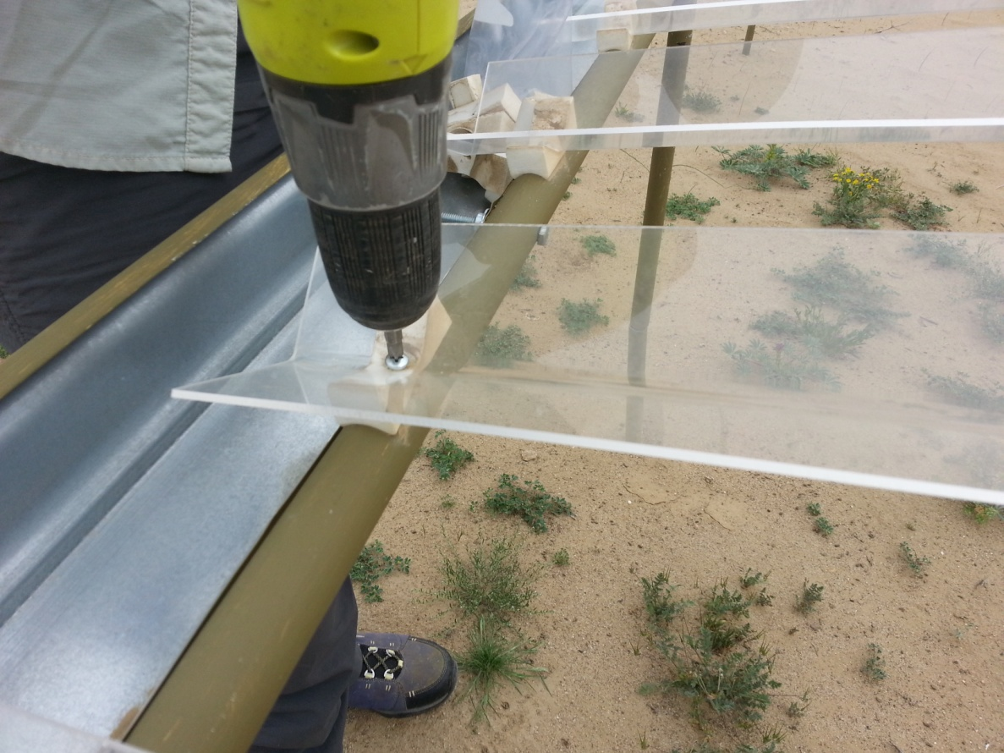
Shingle installation

SHINGLE INSTALLATION:
- Begin at one end of the shelter and install shingles down that row before moving to the next
- Rest a shingle on the frame with the short end (3cm hole) on the high arm and the long end (5cm hole) on the low arm
- Place a piece of foam under the predrilled shingle hole on the high side so that the “V” of the shingle fits into the trough of the foam and insert a screw through both the shingle and the foam piece
- Use the power drill to drive the screw through the shingle and the foam and into the predrilled hole on the high arm. Take care to only tighten the screw until its head barely touches the shingle. You want the shingles to be secure in order to minimize their rocking back and forth, however the shingle will crack if you tighten the screw too much.
- Use the same technique to attach the other end of the shingle with a foam piece underneath it to the predrilled hole in the low arm that lines up with the hole you just used in the high arm. If the shingle appears to be too long or too short try pushing on the frame to adjust the distance between the high and low arms
- Move down the row and repeat this process attaching a shingle to each of the eleven holes on the low arm while skipping every other hole on the high arm until you have installed 44 shingles in this row
- Move to the next row and install 44 more shingles there
- Continue in this manner until all 176 shingles have been installed
- The rain shelter structure is now complete and ready for the installation of an irrigation system

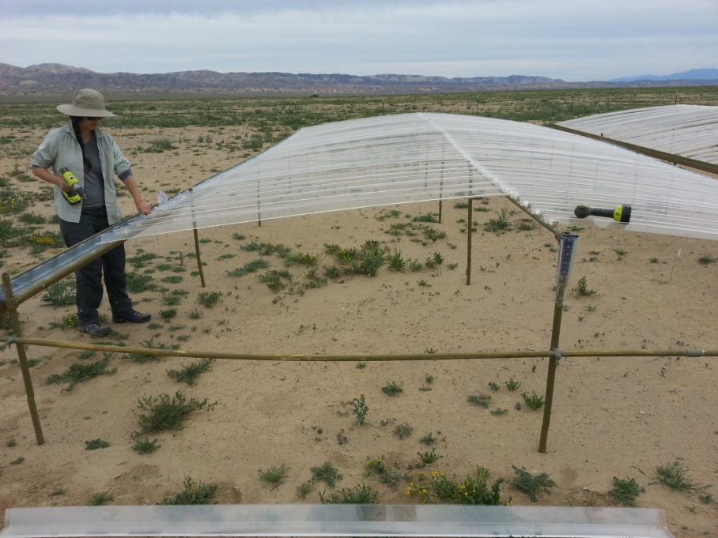
Removing shingles for the dry season

